2
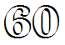
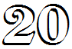
8
7
9
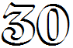
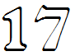
15
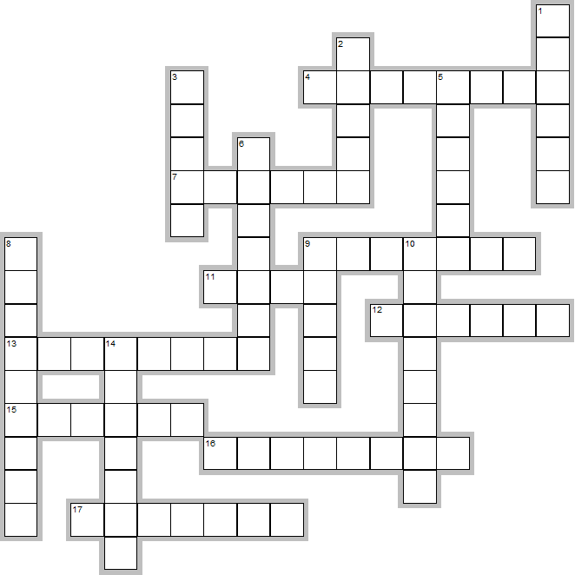
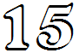

11

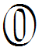
4

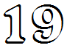

3

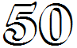
12

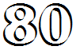
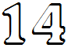
16

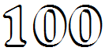
14

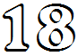
13

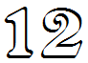
5

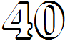
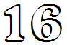
9
10
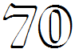
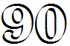
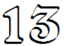
6
17
1

thirty, seventeen, twelve, nineteen, twenty, forty, sixteen, eighty, zero, seventy, thirteen, fourteen, hundred, sixty, eighteen, fifty, ninety, fifteen

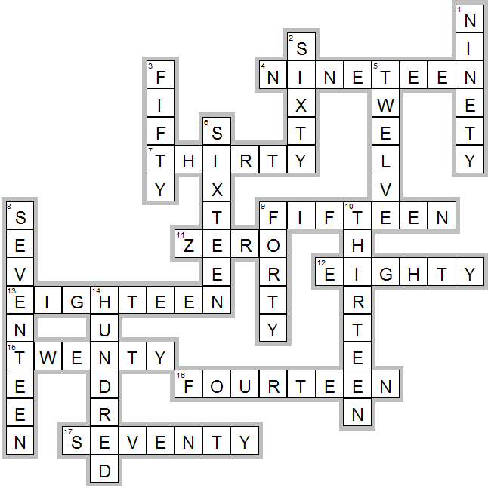
KEY:

