Solution
- Henry is going to play football.
- Henry is going to score some goals.
- Henry is going to kick the ball.
- His parents are going to see the match.
- Paul is going to do snow jumping
- The rabbit is going to jump very fast.
- Robert is going to bungee jump.
- Tom is going to play golf with his father.
- John is going to sail in the lake.
- Willy is going to swim in the pool.
- Martha is going to peel an orange.
- Gloria is going to phone her friend.
- Margaret is going to open the presents.
- You are going to learn some English.
What are they going to do?
1.- play /football Henry is going to play football
2.- score / some goals Henry ………………………………………………
3.- kick/ the ball. Henry ………………………………………………..
4.-his parents/ see/ the match His parents ..……………………………….
5.-Paul/ do/ snow jumping. Paul ………………………………………….
6.-The rabbit/ jump /very fast ……………………………………………….
7.-Robert / bungee jump ……………………………………………….
8.-Tom / play / golf/ with his father ……………………………………………
9.- John /sail / in the lake. ……………………………………………….
10.-Willy / swim/ in the pool ……………………………………………….
11.-Martha /peel / an orange …………………………………………………...
12.-Gloria/ phone/ her friend …………………………………………………..
13.-Margaret/ open/the presents …………………………………………………
14.-You/ learn /some English. ………………………………………….
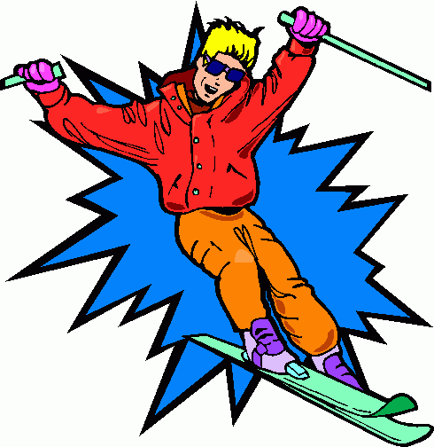
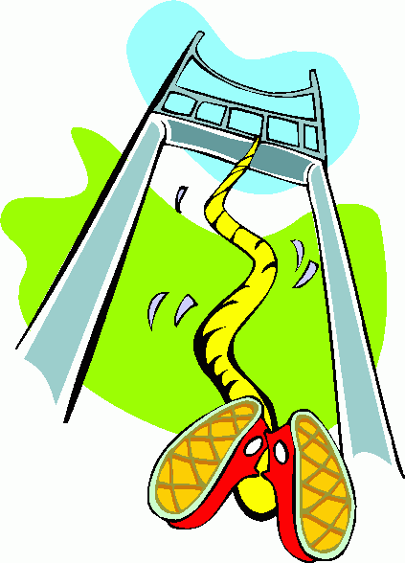
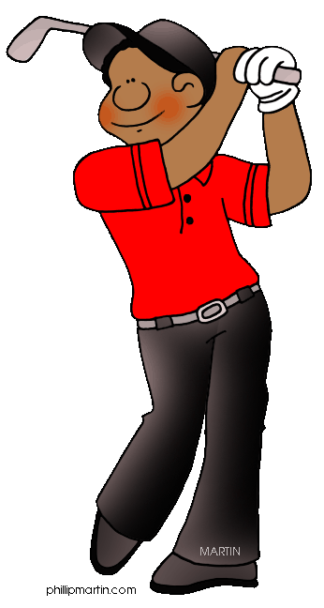
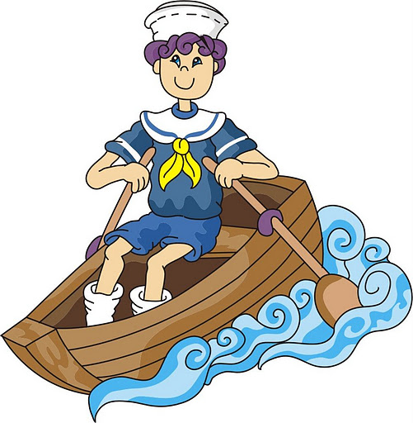
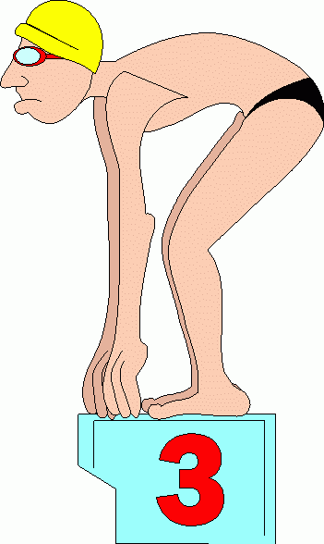
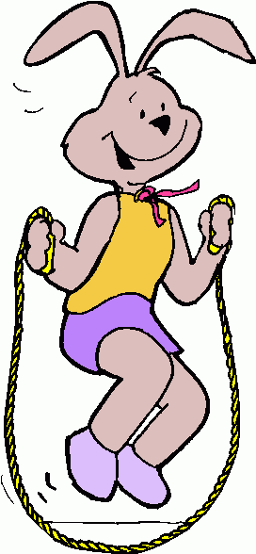
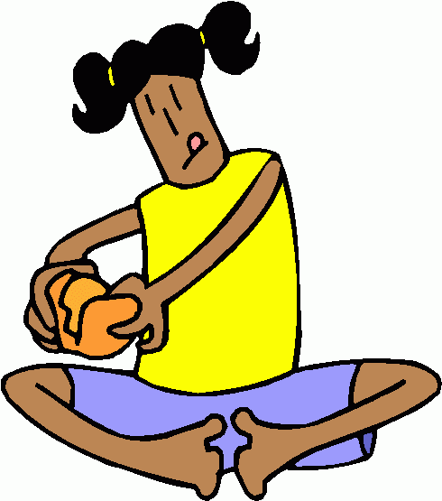
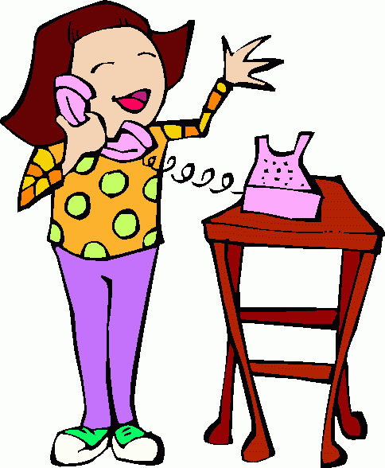
PAUL
HENRY
ROBERT
TOM
JOHN
MARTHA
GLORIA
WILLY
RABBIT

