- What color are her /his clothes?
NAME:
GRADE: ( ) DATE:
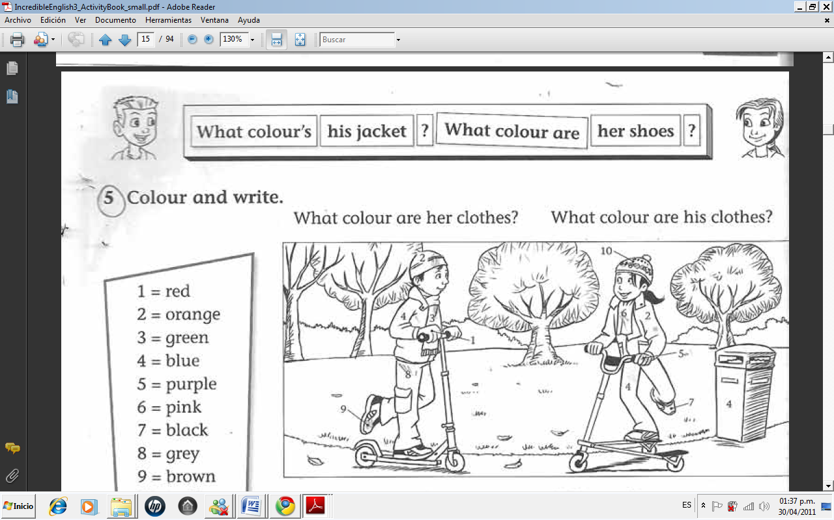

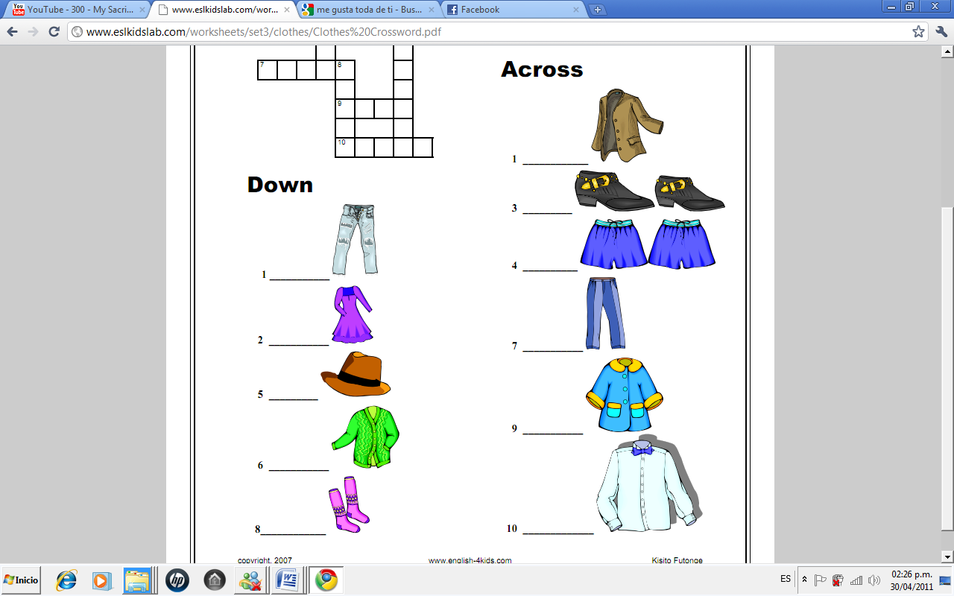
- Complete the crossword:
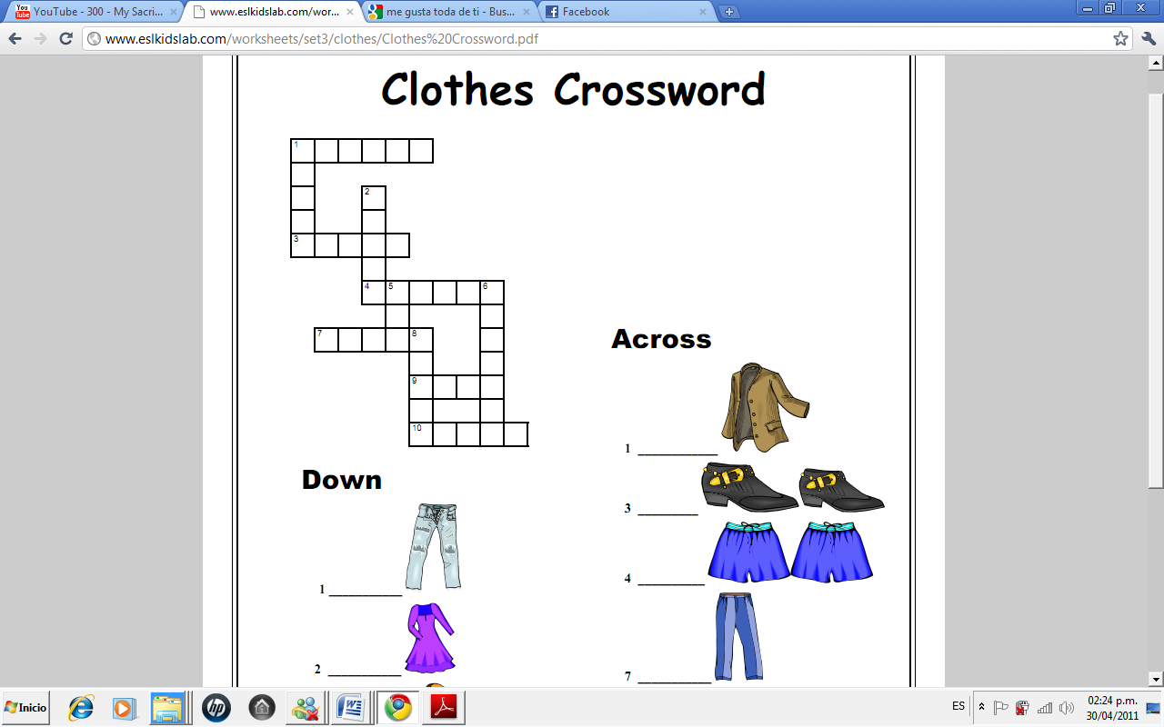

- Unscramble the sentences.
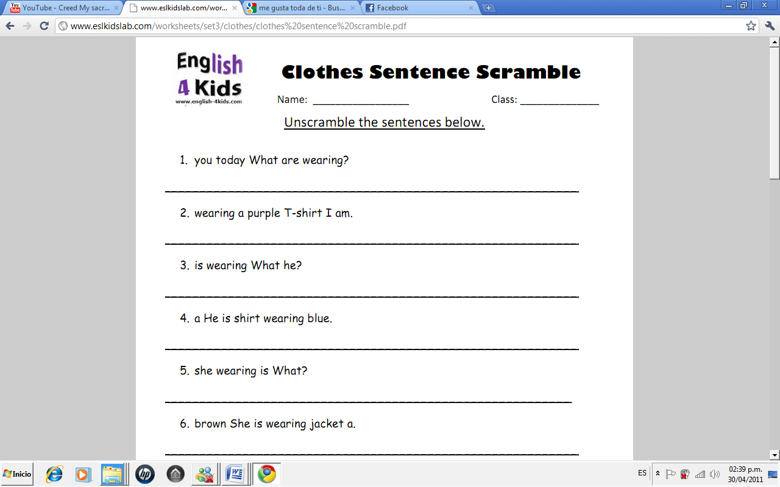
Solution

3. Unscramble the sentences.

- What are you wearing today?
- I am wearing a purple T-shirt.
- What is he wearing?
- He is wearing a blue shirt.
- What is she wearing?
- She is wearing a brown jacket.

