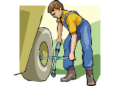
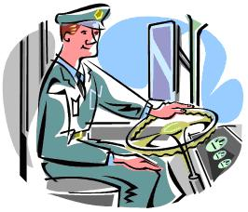



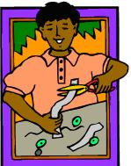
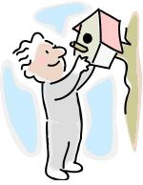
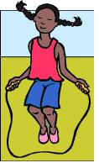
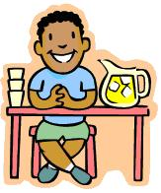



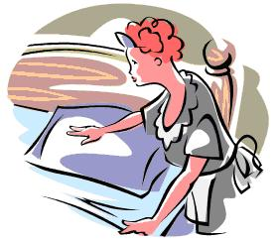


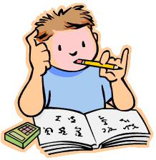
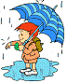


1) Daisy _skipped_ the rope in the garden?
2) Anne ___________________ on her homework.
3) The young lady ___________________ on the beach.
4) Mary ___________________ the litter into the recycling bin.
5) Tom ___________________ lemonade.
6) Joe ___________________ the paper into smaller pieces.
7) The family ___________________ on holiday on Monday.
8) The bus driver ___________________ the bus to the station.
9) Robert ___________________ a birdhouse on the tree.
10) Paul and James ___________________ presents to each other.
11) The lorry driver ___________________ the wheel of the lorry.
12) Jasmine ___________________ the piano.
13) Hanna ___________________ for the test at home.
14) Leila ___________________ in the sea.
15) Kyle ___________________ home.

1
A) SLEEP
M) RUN
N) GIVE
O) CHANGE
C) SWIM
I) SKIP
H) LIE
D) DRIVE
F) DROP
G) CUT
B) SELL
J) STUDY
E) PLAY
L) GO
K) HANG
1) Mum _washed up_ after lunch.
2) The maid ___________________ the beds in the rooms.
3) It ___________________ a lot yesterday.
4) The boys ___________________ after school.
5) The fortune teller ___________________ me my future.
6) Dave ___________________ a slice of pizza.
7) The couple ___________________ TV last night.
8) Tim ___________________ the table.
9) Dad ___________________ a fairy tale to his children.
10) Dave ___________________ a bath.
11) The ambulance ________________ the injured man to the hospital.
12) Owen ___________________ the homework.
13) Fred ___________________ a cold yesterday.
14) Jane ___________________ in the disco last weekend.
15) The couple ___________________ on the bench in the park.

1

Past Simple Tense
A) READ
M) RAIN
N) DO
O) DANCE
K) HAVE
C) SET
I) MAKE
H) SIT
D) FIGHT
F) TELL
G) TAKE
B) CATCH
J) WATCH
E) WASH UP
L) EAT
I - Fill in the sentences with the correct form (past simple) of the appropriate verb, and then match the sentences to the pictures.

II - Fill in the sentences with the correct form (past simple) of the appropriate verb, and then match the sentences to the pictures.

KEY
I  1) Mum washed up after lunch. (E)  2) The maid made the beds in the rooms. (I)  3) It rained a lot yesterday. (M)  4) The boys fought after school. (D)  5) The fortune teller told me my future. (F)  6) Dave ate a slice of pizza. (L)  7) The couple watched TV last night. (J)  8) Tim set the table. (C)  9) Dad read a fairy tale to his children. (A)  10) Dave had a bath. (K)  11) The ambulance took the injured man to the hospital. (G)  12) Owen did the homework. (N)  13) Fred caught a cold yesterday. (B)  14) Jane danced in the disco last weekend. (O)  15) The couple sat on the bench in the park. (H) | 10 | 6 | 13
 | 2 | 9 | 15
 | 11 | 8 | 4
 | 7 | 12 | 3
 | 14 | 5 | 1
II  1) Daisy skipped the rope in the garden? (I)  2) Anne slept on her homework. (A)  3) The young lady lay on the beach. (H)  4) Mary dropped the litter into the recycling bin. (F)  5) Tom sold lemonade. (B)  6) Joe cut the paper into smaller pieces. (G)  7) The family went on holiday on Monday. (L)  8) The bus driver drove the bus to the station. (D)  9) Robert hung a birdhouse on the tree. (K)  10) Paul and James gave presents to each other. (N)  11) The lorry driver changed the wheel of the lorry. (O)  12) Jasmine played the piano. (E)  13) Hanna studied for the test at home. (J)  14) Leila swam in the sea. (C)  15) Kyle ran home. (M) | 14 | 11 | 8
 | 13 | 12 | 2
 | 15 | 9 | 7
 | 10 | 1 | 3
 | 6 | 4 | 5
The background is from http://www.cutecolors.com/

