
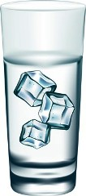
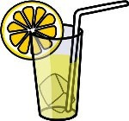
1- Do people drink
water?
A- Yes, they do.

2- .......... Johnny drink
.....................?
A- No,................

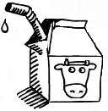
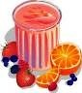
3- .......... babies drink
.....................?
A- Yes, ................

4- .......... your niece drink
...........................?
A- No, ................

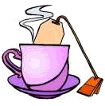
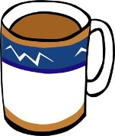
5- .......... Jenny drink
.....................?
A- Yes, ................

6- .......... your aunt drink
.....................?
A- No, ................

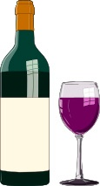
7- .......... Germans drink
.....................?
A- Yes, ................

8- .......... French people drink
.....................?
A- Yes, ................

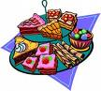
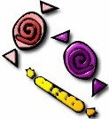
9- ........ you and your sister like
.....................?
A- No, ................

10- .......... children like
.....................?
A- Yes, ................


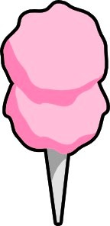
11- .......... your grandma like
.....................?
A- Yes, ................

12- .......... kids like
...........................?
A- Yes, ................

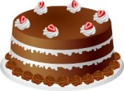
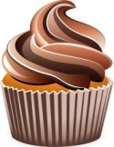
13- .......... you like
.....................?
A- Yes, ................

14- .......... Mrs.Ogden like
.....................?
A- No, ................

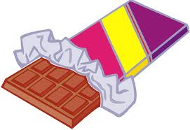

15- .......... your cat like
.....................?
A- No, ................

16- .......... English Preople like
.....................?
A- Yes, ................

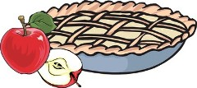
17- .......... your nephew like
.....................?
A- No,................

18- .......... Martha like
........................?
A- Yes, ................

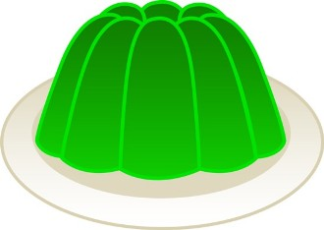
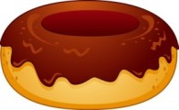
19- .......... Jack’s friends like
.....................?
A- No,................

20- .......... your uncle like
.....................?
A- Yes, ................

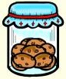
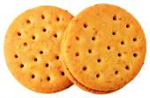
21- .......... your mum like
.....................?
A- Yes, ................

22- .......... you like
.....................?
A- Yes, ................

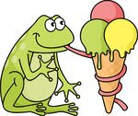


23- ............ Kermit like
..........................?
A- Yes, ................

24- ............ children like
.........................?
A- Yes, ................

1- .... DO .... people drink
.... WATER .... ?
A- Yes, THEY DO.

2- DOES Johnny drink
......LEMONADE.......?
A- No, HE DOESN’T.

3- DO babies drink
........MILK.........?
A- Yes, THEY DO.

4- DOES your niece drink
........ FRUIT JUICE ..........?
A- No, SHE DOESN’T.

5- DOES Jenny drink
........ TEA ........ ?
A- Yes, SHE DOES.
6- DOES your aunt drink
........ COFFEE ........ ?
A- No, SHE DOESN’T.

7- DO Germans drink
......... BEER ........... ?
A- Yes, THEY DO.
8- DO French people drink
......... WINE ........... ?
A- Yes, THEY DO.

9- DO you and your sister like
..........DESSERTS.......... ?
A- Yes, WE DO.
10- DO children like
.........SWEETS.......... ?
A- Yes, THEY DO.

11- DOES your grandma like
.........CANDY........... ?
A- Yes, SHE DOES.
12- DO kids like
.........CANDYFLOSS........... ?
A- Yes, THEY DO.

13- DO you like
..........CAKE.......... ?
A- Yes, I DO.
14- DOES Mrs. Ogden like
...........CUPCAKE......... ?
A- No, SHE DOESN’T.

15- DOES your cat like
..........CHOCOLATE.......... ?
A- No, IT DOESN’T.
16- DO English people like
........PUDDING....... ?
A- Yes, THEY DO.

17- DO your nephew like
........ MUFFIN ....... ?
A- No, HE DOESN’T.
18- DO Martha like
.......APPLE PIE........ ?
A- Yes, SHE DOES.

19- DO Jack’s friends like
........ JELLY........ ?
A- No, THEY DON’T.
20- DOES your uncle like
........DOUGHNUT....... ?
A- Yes, HE DOES.

21- DOES your mum like
.......COOKIES...... ?
A- Yes, SHE DOES.
22- DO you like
......BISCUITS....... ?
A- Yes, I DO.

23- DOES Kermit like
...... ICECREAM ......?
A- Yes, IT DOES.
24- DO children like
...... ICE LOLLIES ?
A- Yes, THEY DO.

