
Some
Examples:
I have got some friends.
Mary does some housework every day.
The noun
countable nouns are in plural form
uncountable nouns are in singular form
The sentence

with affirmative statements

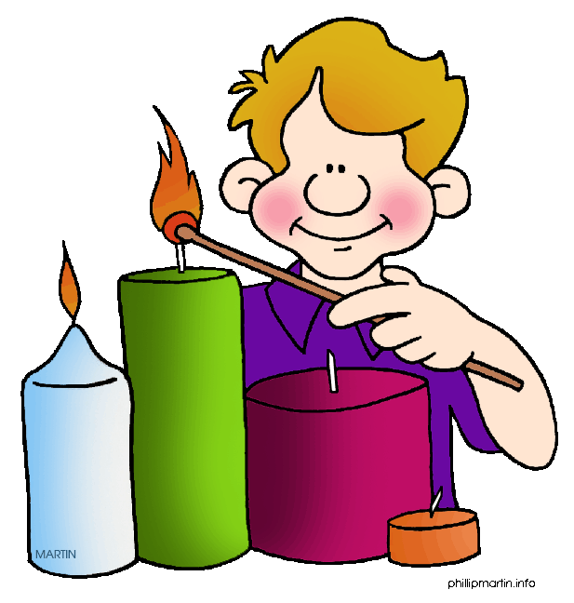

Any
Examples:
Did Larry buy any candles?
Kevin doesn’t eat any cheese.
The sentence

in questions and negative sentences
or in sentences with one of these words: without, never, seldom, rarely, hardly, …
The noun
countable nouns are in plural form
uncountable nouns are in singular form

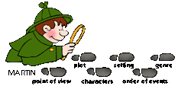

Task 1
Task 2
Write the correct determiner
(some or any) into the sentences.
- There are _______ apples in my basket.
- Do you buy _______ books?
- There isn’t _______ milk at home.
- I eat _______ soup.
- These are _______ pens.
- Have they got _______ money?
- I am writing _______ tests today.
- You can’t read _______ newspapers in this café.
- Do you collect _______ stickers?
- _______ children are sitting in the park.
- My son has _______ homework.
- Does her daughter listen to _______ music?
- Are there _______ films on TV?
- Sssh! There’s _______ noise outside.
- There aren’t _______ cats in the garden.
Write the correct determiner
(some or any) into the sentences.
- Grandpa gave ______ chocolate to the kids.
- Mike hasn’t got ______ mugs.
- My friends never paint ______ pictures.
- There’s ______ sand in my shoes.
- Steve did his homework without ______ help.
- Paul is thinking of ______ good memories.
- We often eat ______ ham for breakfast.
- Diane keeps ______ photos in her bag.
- There’s hardly ______ honey in the jar.
- I can rarely take ______ photos because I haven’t got a camera.
- Susan has ______ coffee and cake in the afternoons.
- Did you buy ______ butter yesterday?
- They have ______ surprises for us.
- We seldom pick ______ flowers.
- I need ______ advice.




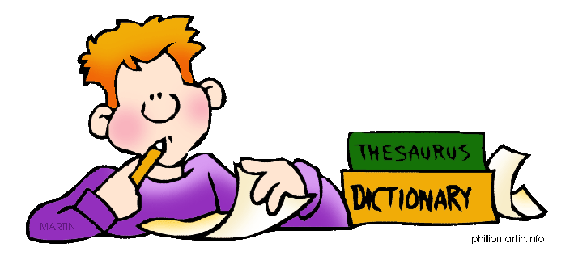

Task 3

Underline the correct word.
1) I read some/any books on my holiday. | 9) Sam always buys some / any bread.
2) Jim hasn’t got any money/moneys for the ticket. | 10) I didn’t put some / any salt into the soup yesterday.
3) Lisa wrote some letter/letters to her aunt. | 11) Have your parents got any free time / times?
4) Is / Are there any bananas in your bag? | 12) Can you see some / any clouds in the sky?
5) Did you eat some / any rice? | 13) There is / are some cheese in the fridge.
6) There isn’t / aren’t any lemonade in the bottle. | 14) Tina has got some box / boxes.
7) My father asked some information / informations about the new service. | 15) Does / Do any students leave their homework at home?
8) Some cats has / have got big ears.

Task 1
- There are some apples in my basket.
- Do you buy any books?
- There isn’t any milk at home.
- I eat some soup.
- These are some pens.
- Have they got any money?
- I am writing some tests today.
- You can’t read any newspapers in this café.
- Do you collect any stickers?
- Some children are sitting in the park.
- My son has some homework.
- Does her daughter listen to any music?
- Are there any films on TV?
- Sssh! There’s some noise outside.
- There aren’t any cats in the garden.

Task 2
- Grandpa gave some chocolate to the kids.
- Mike hasn’t got any mugs.
- My friends never paint any pictures.
- There’s some sand in my shoes.
- Steve did his homework without any help.
- Paul is thinking of some good memories.
- We often eat some ham for breakfast.
- Diane keeps some photos in her bag.
- There’s hardly any honey in the jar.
- I can rarely take any photos because I haven’t got a camera.
- Susan has some coffee and cake in the afternoons.
- Did you buy any butter yesterday?
- They have some surprises for us.
- We seldom pick any flowers.
- I need some advice.

Task 3
1) I read some/any books on my holiday.
2) Jim hasn’t got any money/moneys for the ticket.
3) Lisa wrote some letter/letters to her aunt.
4) Is / Are there any bananas in your bag?
5) Did you eat some / any rice?
6) There isn’t / aren’t any lemonade in the bottle.
7) My father asked some information / informations about the new service.
8) Some cats has / have got big ears.
9) Sam always buys some / any bread.
10) I didn’t put some / any salt into the soup yesterday.
11) Have your parents got any free time / times?
12) Can you see some / any clouds in the sky?
13) There is / are some cheese in the fridge.
14) Tina has got some box / boxes.
15) Does / Do any students leave their homework at home?
http://www.phillipmartin.com/

