Story Time
Do you know these popular stories?
1)Hansel and Gretel 2)Little Red Riding Hood 3)Sherlock Holmes 4) Beauty and the Beast 5)Robin Hood 6)The Little Mermaid
A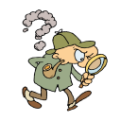 B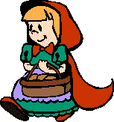 C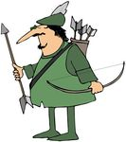 D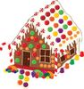 E 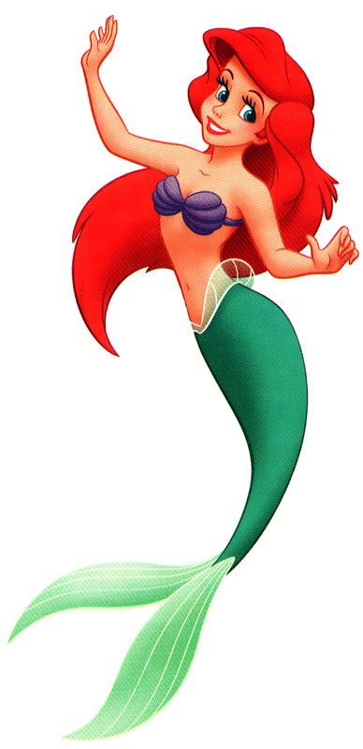 F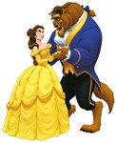
Did you read stories when you were young? Which one was your favourite?
Complete the stories with the words in the box:
Sleeping Beauty
lived lived woke slept took was cast grew came married cut saw
A long time ago there _________ a beautiful princess . She __________in a very high tower. A wicked fairy ___________ a spell and the princess ________ for a hundred years. A big forest _________ around the tower. One day a handsome prince ________ to the tower. He ________ his sword and _________ the trees. He ________ the princess and ______ her with a kiss. The prince ____________ the princess and they ______ happily ever after.
The Three Little Pigs
made tried ate built were lived fell blew was used came
Once upon a time there ___________ three little pigs. One _________ a house with straw, one _________ a house with wood and the other _________ bricks. One day a big bad wolf _________ and _________ to destroy the houses. He ________ on each house. The houses of straw and wood _________ down and he ______ the pigs. The house of bricks ________ very strong so the final pig _______ a long and happy life.
Now complete the tables with the past simple verbs from the stories:
Present simple | Past simple
live  sleep  grow  cut  cast  marry  be  take | ……………………..  ……………………..  ……………………..  ……………………..  ……………………..  ……………………..  ……………………..  ……………………..

Present simple | Past simple
be  eat  make  build  use  blow  try  fall | ……………………..  ……………………..  ……………………..  ……………………..  ……………………..  ……………………..  ……………………..  ……………………..

Answers:
Answers:

Sleeping Beauty
A long time ago there was a beautiful princess . She lived in a very high tower. A wicked fairy cast a spell and the princess splept for a hundred years. A big forest grew around the tower. One day a handsome prince came to the tower. He took his sword and cut the trees. He saw the princess and woke her with a kiss. The prince married the princess and they lived happily ever after.
The Three Little Pigs
Once upon a time there were three little pigs. One built a house with straw, one made a house with wood and the other used bricks. One day a big bad wolf came and tried to destroy the houses. He blew on each house. The houses of straw and wood fell down and he ate the pigs. The house of bricks was very strong so the final pig lived a long and happy life.

Optional song

There was a princess long ago, long ago, long ago, there was a princess long ago, long long ago.
IF DOING IN A CIRCLE THEN WE ALL CURTSY/BOW; IF NOT PRINCESS IN MIDDLE DANCES ABOUT.
And she lived in a big high tower, a big high tower, a big high tower, and she lived in a big high tower, long long ago
WE PUT HANDS IN "TRIANGLE" SHAPE TO MAKE TOWER, PRINCESS STILL DANCES AND WE ALL DO TOWER HANDS
A wicked fairy cast a spell etc
FAIRY CHASES PRINCESS ABOUT, THEN TAPS HER HEAD AS CASTING A SPELL. ALL- CAST SPELL WITH "WANDS"
The princess slept for a hundred years etc
PRINCESS LIES IN MIDDLE OF CIRCLE SLEEPING; ALL PUT HEAD ON HANDS AS SLEEPING ACTION.
A great big forest grew around etc
SMALL GROUP KIDS CHOSEN TO HOLD HANDS AROUND SLEEPING PRINCESS AND BE FOREST. IF ALL DOING IT WE CROSS ARMS AND HOLD (VERY AMUSING TO GET DONE!!!)
A handsome prince came riding by etc
PRINCE RUNS/GALLOPS ROUND CIRCLE, IF ALL DOING IT THEN JUST KIND OF GALLOP ON SPOT!?!
He took his sword and cut the trees etc
PRINCE CHOPS TREES WITH ARM; IF ALL THEN ALL PRETEND TO CUT TREES
He woke the princess with a kiss etc
PRINCE GIVES PRINCESS A WEE KISS ON HEAD/CHEEK/LIPS WHATEVER OR BLOWS ONE! (NO FORCING!) IF ALL THEN ALL BLOW KISSES
The wedding bells go ding dang ding etc
ALL WITH HANDS PRETEND TO RING BELLS; PRINCE AND PRINCESS DANCE IN MIDDLE
And everybodys happy now etc
ALL HAPPY, CLAPPING, DANCING, JUMPING ETC

